Kerubel Kebede. Keyun Liu. Mateo Ramirez

12/15/2021

Professor Galina Madjaroff Reitz

Group 10 Final Project

Introduction

Crashed makes reporting car accidents and connecting with an insurance company agent much faster than the regular process. Reports location, detailed information of both cars involved in the accident, user is able to upload the photo of the damage from the accidents, user is able to scan the insurance information and upload into the app for the insurance information agent. Insurance coverage information and other important insurance related information will be displayed on the app based on the type of information the user has. The stakeholders for this app would be insurance companies.

**Scope:**

Specific Insurance company promotions, Insurance deals, and car dealerships would be excluded because our app would be solely focused on being a mediator between customers and insurance companies. Our job is not to promote any specific insurance companies. We also do not advertise or promote car dealerships. Insurance companies, drivers, insurance company agents, would be included because our app is for mediating between insurance company agents and drivers in order to upload information of car accidents and insurance company information. Our app will be targeting young drivers and parents but that does not mean older drivers would not be able to use the app. Crashed accepts any user age.

**User Types**

Description of intended user population:

● We would target new young drivers, for they have higher liability of getting into car accidents and they would need help going through the process of reporting the accident to their insurance company. Another reason we would target young drivers, they are more exposed to doing things through technology so it would be familiar and easy for them rather than the regular process. Possible story/scenario of a user

● Let’s say a 19 year old kid just got into his first car accident, he calls the police, he is not injured but he is still in shock and needs help to go through the process of reporting the accident to his insurance company. The app would have a step by step instruction on how to report this accident and provide the right information to the insurance company agent. Brainstorm of infrequent users

● Some users that would benefit from this app in a less direct way would be parents that are trying to get their new driver kids to get used to driving responsibilities. Since the app will help the new driver carry out the necessary process of reporting an accident to his insurance company, by making the needed information available to the insurance company agent. Therefore being the mediator between the driver and the insurance company agent. Other infrequent users would be other employees at insurance companies that would likely use information within the app to help a customer.

Tasks by user type:

● After the user collects the necessary information of the crash participant such as full name, contact information, insurance company and policy number, drivers license, and plate number. All this information can be inputted into the app to be saved and organized.

● The user can take their accident information and upload it to their respective insurance to be processed.

● Once the respective insurance is inputted in the app, an agent from the user’s respective insurance can be connected to so the user can discuss what steps to take next.

GETTING DATA AND INTEGRATING WITH OTHER SYSTEMS

How our app will be populated with data for its metadata records.

* Records will be created by users filling out forms in the app because they need to input and upload the accident data they have onto the app
* Records will not be created by insurance agents, but they will be managed by staff.
* Records will be saved into the users insurance company records however we would need to have a list of databases that would need to save the users crash reports for later reference if needed.
* The database will extract data inputted by users accident information/
* Our app will use external information systems such as cameras/photos so the user can take pictures of the accident and upload it onto their report. Any personal information needed for the accident report will be inputted in by the user.
* Our primary source of information needs to be extracted by their user who is willing to input their accident and personal information that needs to be submitted to their respective insurance companies.
* Will records be created by users who fill out forms in the app (like EBay, AirBnB, dating apps)?

MARKET COMPARISON AND APP RATIONALE

* Describe the current marketplace for apps, websites, products, and services that offer similar functionality to your app. (Short paragraph + bulleted list or table) .
* After searching, products that our similar to our are mainly focused with major accidents that would put the users life in immediate danger. However, there are some accident report apps that are focused on helping the user report accident information.
* Most apps for this type of market are nonexistent in the app store or are doing very poorly. Some of these same apps are ones that help users with compiling information for accidents. However, some notable ones have more than one main way to help users such as the phone acting as a dashcam or calling the police immediately.
* Our app can take this opportunity to work in this untapped market. One difference between existing apps and our apps is the relationship our app has with insurance companies to make the process easier. Most existing similar apps do not send this information to the user's respective insurance company and only helps the user collect data together. Our approach removes the complicated and long process of getting in contact with insurance companies to file accident reports and acts as a middle man to the process instead of leaving the task to the user. We are interested in developing an app of this type because it removes unnecessary difficulty in the process of accidents that happen.

SOCIAL IMPLICATIONS

Potential risks

* The potential risks would be information accessibility on our part. When it comes to accessing information of the user, there might be some risks regarding how we access it. Would it be through the company? Or would it be directly through the user. Since our app would tied to insurance companies, meaning insurance companies would promote our app as colleges promote my coalition for applications, it’s important to discuss how we gather information from the user. If we use information provided by the user to the insurance company, we might have a risk of accessing information the user does not authorize to share with the app. Therefore, we have to ways of dealing with these risks. We can inform the user, if they agree to use the app we would access all information that is accessible to the insurance companies, or we would ask the user directly to upload and enter information needed instead of importing information from the insurance companies. I think that the risks for violation would be reduced if we either inform the user of information being imported from the insurance company or ask the user to enter information directly to the app. The benefits of to the rights and values of users is that through these precautions and rules and regulations, people’s information will be protected. These rules and regulations will protect the user from things such as identity theft and sensitive information being shared with unwanted parties.

Laws and Organizational Policies

* Our app complies with the Consumer Privacy Insurance Act in insurance. Since our app is embedded within insurance companies, and we are promoted by insurance company related laws and organizational policies. One of the laws is a privacy law called the Consumer Privacy Insurance Act.

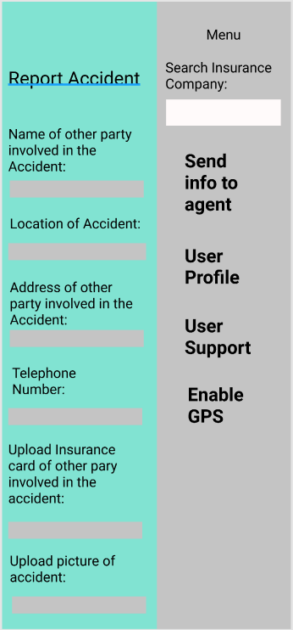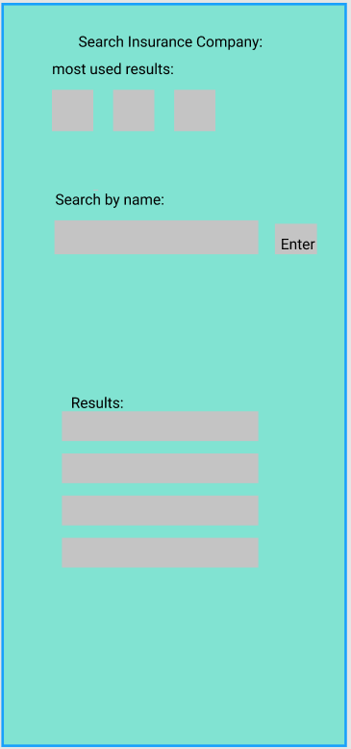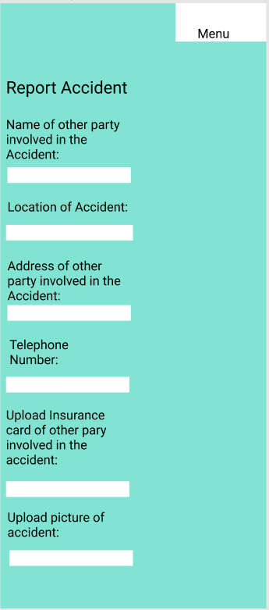

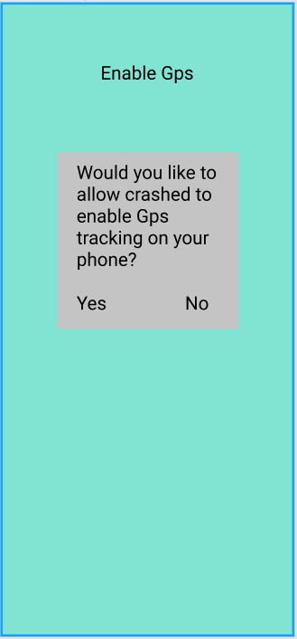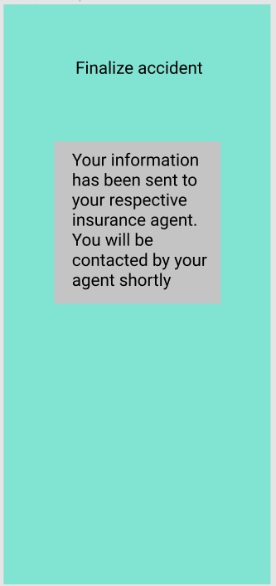

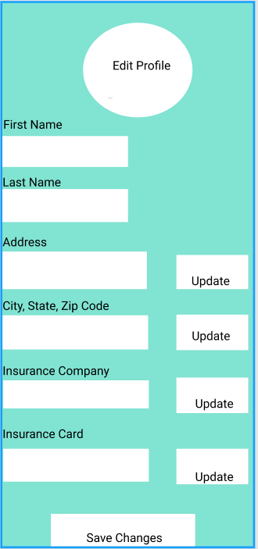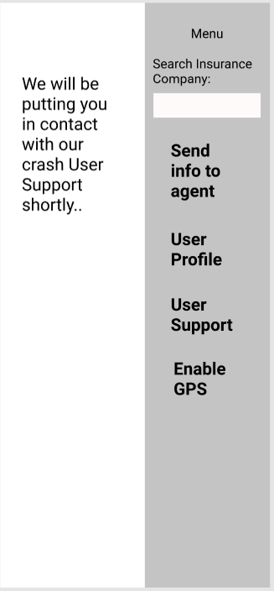

Metadata Schema

Component 1: Summary Item Type Tables

Item Type 1 User (The users personal info and data):

| **Name of Property** | **Description of property** | **Example Value** |
| --- | --- | --- |
| Address | The users personal address that they input into the system | 1234 Buckingham Road |
| First Name | The first name of the user | John |
| Telephone | The users telephone number | 240720193 |

Item Type 2 Insurance Company:

| **Name of Property** | **Description of property** | **Example Value** |
| --- | --- | --- |
| Insurance Company Name | The name of the insurance company searched for | Allstate |
| Insurance prices | The rates the insurance company provides | Allstate customer can expect to pay $1,787 |
| Contact Agent (insurer) | Connects user with agent associated with insurance company | Directly connecting user to insurance agent by telephone |
| Insurance Information | The User’s Insurance information (insurance card) | Contains the User’s insurance  information |

Component 2: Detailed Property Information Tables

| Property Name | | Address |
| --- | --- | --- |
| Item Type | | User |
| How will this property be encoded? | Data Type | *String* |
| Select ONE of these three rows to fill out: | Controlled Vocabulary | Link to existing controlled vocab, OR List all terms here if fewer than 10, OR Add an appendix to the end of this document to a controlled vocab with more than10 terms |
|  | Embedded Object | *Name item type of embedded object here* |

| Property Name | | **Accident photo** |
| --- | --- | --- |
| Item Type | | User |
| How will this property be encoded? | Data Type |  |
| Select ONE of these three rows to fill out: | Controlled Vocabulary | Link to existing controlled vocab, OR List all terms here if fewer than 10, OR Add an appendix to the end of this document to a controlled vocab with more than10 terms |
|  | Embedded Object | PNG, JPEG image |
| Mandatory property? (yes/no) | | Yes |
| Sorting property? (yes/no) | | No |
| Filtering property? (yes/no) | | No |

| Property Name | | **Telephone** |
| --- | --- | --- |
| Item Type | | User |
| How will this property be encoded? | Data Type | String |
| Select ONE of these three rows to fill out: | Controlled Vocabulary | Link to existing controlled vocab, OR List all terms here if fewer than 10, OR Add an appendix to the end of this document to a controlled vocab with more than10 terms |
|  | Embedded Object | Number text |
| Mandatory property? (yes/no) | | No |
| Sorting property? (yes/no) | | No |
| Filtering property? (yes/no) | | No |

| Property Name | | Insurance Company Name |
| --- | --- | --- |
| Item Type | | Insurance Company |
| How will this property be encoded? | Data Type | String |
| Select ONE of these three rows to fill out: | Controlled Vocabulary | Contact Agent (insurer) RT Insurance Claim |
|  | Embedded Object |  |
| Mandatory property? (yes/no) | | No |
| Sorting property? (yes/no) | | No |
| Filtering property? (yes/no) | | No |

| Property Name | | Insurance Information/card |
| --- | --- | --- |
| Item Type | | Insurance Company |
| How will this property be encoded? | Data Type |  |
| Select ONE of these three rows to fill out: | Controlled Vocabulary |  |
|  | Embedded Object | PNG, JPEG image |
| Mandatory property? (yes/no) | | Yes |
| Sorting property? (yes/no) | | No |
| Filtering property? (yes/no) | | No |

| Property Name | | Location of accident |
| --- | --- | --- |
| Item Type | | User |
| How will this property be encoded? | Data Type | String |
| Select ONE of these three rows to fill out: | Controlled Vocabulary |  |
|  | Embedded Object |  |
| Mandatory property? (yes/no) | | Yes |
| Sorting property? (yes/no) | | No |
| Filtering property? (yes/no) | | No |

| Property Name | | First Name/Last Name |
| --- | --- | --- |
| Item Type | | User |
| How will this property be encoded? | Data Type | String |
| Select ONE of these three rows to fill out: | Controlled Vocabulary |  |
|  | Embedded Object |  |
| Mandatory property? (yes/no) | | Yes |
| Sorting property? (yes/no) | | No |
| Filtering property? (yes/no) | | No |

| Property Name | | Other party address |
| --- | --- | --- |
| Item Type | | User |
| How will this property be encoded? | Data Type | String, Integer |
| Select ONE of these three rows to fill out: | Controlled Vocabulary |  |
|  | Embedded Object |  |
| Mandatory property? (yes/no) | | Yes |
| Sorting property? (yes/no) | | No |
| Filtering property? (yes/no) | | No |

| Property Name | | Search Insurance Company |
| --- | --- | --- |
| Item Type | | Insurance Company |
| How will this property be encoded? | Data Type | String, Integer |
| Select ONE of these three rows to fill out: | Controlled Vocabulary |  |
|  | Embedded Object |  |
| Mandatory property? (yes/no) | | Yes |
| Sorting property? (yes/no) | | Yes |
| Filtering property? (yes/no) | | Yes |

Metadata Records

User first name: John

User middle name: Andy

User last name: Smith

User Address, zip code, city, state: 14427 John Hopkins Road, Gaithersburg, 20991 MD

User Insurance company: Allstate

User Insurance Card: BlueCross BlueShield

Location of accident: John Hopkins Road

Picture of accident: Jpeg or PNG image needed

User date of birth: 02/13/1966

Car model: ultimata

Car make: nissan

Car year: 2008

Drivers license card image: Jpeg or PNG needed

User telephone number: 301-992-2003

Metadata records

User information

First Name: James

Middle Name: Gregory

Last Name: Bond

Date of Birth: 09/14/1998

Address: 007 double o seven dr, London, England

Telephone: 315 698 1455

Email: double007@spyagents.com

Car Model: Aston Martin

Car Year: 1964

Car Make: DB5

Driver’s License Card: Photo upload:

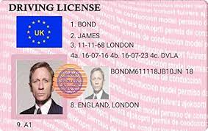

Insurance Company Name: State Farm

Insurance Card: Photo upload:

